Исследовательская работа по английскому языку на тему:

WAYS OF LEARNING ENGLISH ON THE INTERNET

Выполнила:
ученица 10 «А» класса
гимназии №524
Московского района
Сербина Лариса

Научный руководитель:
Федотова Татьяна Сергеевна

Санкт-Петербург
2013
Contents:
- Introduction ………………………………………………………………..3
- Main part
- Global language………………………………………………………...6
- Traditional ways of learning English versus Internet-based options......8
- English on the Internet………………………………………………...10
- Positive and negative sides of Internet learning……………………....14
- Recourses most popular with my schoolmates …………………….....16
- Conclusion………………………………………………………………..17
- Reference list……………………………………………………………..19
- Supplement……………………………………………………………….20

Содержание:
- Вступление…………………………………………………………………3
- Основная часть
- Язык мира………………………………………………………………6
- Традиционные способы изучения английского языка в сравнении с интернет вариантом……………………………………………………8
- Английский язык в интернете……………………………………….10
- Положительные и отрицательные черты интернет обучения…..…14
- Наиболее популярные ресурсы среди одноклассников…………....16
- Заключение…………………………………………………………….....17
- Список литературы……………………………………………………....19
- Приложения……………………………………………………………....20

I.INTRODUCTION
Language is really important nowadays. Many years ago people tried to learn English travelling around the world, with native-speaking teachers or living abroad, but advances in technology have changed our lives a lot and we now have an opportunity to study in different, for example, via the Internet.
Now it is difficult to understand how to live without computers and the Internet. Today using computers we can find important information for the reports, learn different interesting facts about history, foreign countries and people or simply listen to music, watch films and communicate with friends on the Internet. We can even buy tickets and book seats in planes, hotels etc. Any person who can use a computer can do it easily and of course it saves money and time.
I’m sure the Internet has become an essential part of modern life. It is a global system of computers, all linked to one another. Information can be sent from one machine to any other machine which is online. People use the Internet in different areas of their life. Nowadays students can get information from different internet channels: books, films, sites, newspapers and magazines. If we have a question on any subject from history to mathematics or philosophy to geography, the answer can be found on the Net. We can find the latest news or what the weather is going to be like. We can buy food and clothes from internet-shops. If you don’t want to go to a travel agent and pay a fee, you can buy your airplane ticket on the net. Today people use the Internet learning different foreign languages too. More and more people try to find a new ways to learn another language.
There are a lot of opportunities on the Net to improve your knowledge. But not all people who are going to study languages with the help of Internet resources know which ones are the most helpful. What sites are better for beginners and what will suit advanced learners? What benefits will users have? Is the Internet learning the future of the education?
To answer these questions I would like to start comparing with traditional and modern ways of learning, then I will carefully explore facilities for learning languages provided by the Net to bring out their influence on the process of study thus I will find advantages and disadvantages of them. Finally I hope to understand which one is the best. I have also made a research among my classmates and friends to understand which way is the most popular.
We live in the world of modern technologies that is why I think that this theme is up-to-date and I want to study it from different sides. I have decided to take learning English as an example because it is the most widely spoken language in the world and there is hardly anything in our lives that is not affected by it.

II.MAIN PART
Global language
Language belongs to each of us. Everyone uses words. What is it about language that makes people so curious? The answer is that there is almost nothing in our lives that is not touched by language. We live in and by language. We all speak and we all listen: so we are all interested in the origin of words, in how they appear and die.
The rise of English is a story of wonderful success. When Julius Caesar landed in Britain nearly two thousand years ago, English did not exist. Five hundred years later, in the 5th century, English was already spoken by the people who inhabited Great Britain but they were not many, and their English was not the language we know today. Nearly a thousand years later, at the end of the 16th century, when William Shakespeare created his works, English was the native language of about 6 million Englishmen. At that time English was not used anywhere else except Great Britain.
Nowadays, four hundred years later, 750 million people all over the world use English, and half of those speak it as a mother tongue (Supplement 1
Map “The spread of English”). Of all the 2700 world languages English is one of the richest. For example, compare English, German and French: English has a vocabulary of about 500 000 words, German - 185 000, and French -fewer than 100 000. At the beginning of the 21st century English is more widely spoken and written than any other language has ever been. It has become the language of the planet, the first truly global language. Three quarters of the world's mail and its telexes and telegrammes are in English. More than half of the world s scientific periodicals and eighty per cent of the information in the world's computers are also in English. English is the main language of business. It is the language of sports: the official language of the Olympics.
Nowadays more and more people begin learning English to be on the same wave with the world. If you want to achieve good results in your life – you need to know English rather well. If you speak English you can be sure that you will find the road or buy food in a restaurant in any country. Without knowing English you might not be able to find a prestigious job in a successful company, because every good company anyway keeps in touch with foreign branch offices and other companies in all parts of the world.
The English language surrounds us like a sea, and like the waters of a deep sea it is full of mysteries. English is and has always been constantly changing. Some words die, some change their meanings and all the time new words appear in the language. That is why we need to learn day by day, because it is really important to use up-to-date language.
Whether it is travel, business, education, or the arts, English is your gateway to the world. Although Chinese has more native speakers, no language rivals English as the global lingua franca, with over 1 billion people worldwide learning the language. It’s the language of United States, the United Kingdom, Canada, Australia, and spoken in many other countries. Sing it or quote it—songs, movies and television are popular ways that people learn English, and due to its global reach, the language is in a constant process of transformation. From its beginnings in the German invasion of Britannia in the 5thcentury to the professional lingo and slang of today, English is a vibrant, living language.
As we see English is an essential part of modern life, so it is useful to know ways, how to learn it.

Traditional ways of learning English versus Internet-based options
Traditionally we begin learning English at school. Pupils need text books, work books, books for extra reading, exercise books and other special things for successful learning. At school children are taught by teachers in the classrooms. They begin their learning from the alphabet and day by day they improve their reading, writing and learn different grammar rules. Pupils need to do a lot of homework as they have English lessons at schools almost every day. Sometimes students have to write reports and do special tasks so they need extra literature. Some years ago they had to go to the libraries or buy books to look for useful information and exercises; today Internet makes this work easier. Today we can find all necessary books on the Internet sitting in front of your computer in your favourite armchair.
Reading and translating texts is another traditional way to learn English. It has always been very difficult and needed a lot of time and concentration. It was not easy or cheap to have some good dictionaries at home. Internet has solved this problem too. Now we can find dictionaries and on-line translators on the Net (supplement 2 “On-line translator”). The information will be set in a more organized way so it will make your translation better and you will be able to do more work than if you use a paper version.
At present, Internet resources are also widely used, for example, teachers often send tasks to their pupils in the electronic diaries and students send their homework on the Net. So they save time and do not have to carry all these books and exercise books to school. It is really convenient for teachers and pupils that some tasks can be checked on-line, but quite recently teachers spent hours checking students’ mistakes. Sometimes instead of taking parts in traditional Olympiads of English language students have opportunities to check their knowledge on-line for example in Macmillan Olympiads which are popular in our country. All these things facilitate the access to resources for learning English.
People who never learnt English at school or those who want to improve their language decide to enter some courses. Traditionally courses work two or three times a week and last about four hours. You need a lot of time to get to the place where you have courses. It is rather hard for grownups to study after working day. In this way Internet can also help you. First you need is to find a suitable course, register there and begin to study at home any time you can. During your on-line course you will be sent tasks on electronic mail, you will do them and send back to your teacher. Doing such courses will help you to become more disciplined and teach you not to miss lessons. It is a good way of learning English for beginners.
Many people prefer learning English individually, so they need personal teachers or tutors, furthermore, they want an English-speaking person to teach them. It is far more difficult to find such teacher in Russia, but in the Internet you can do it. You can connect with native speakers all over the world and have on-line lessons.
If you have enough money you can also go to another country where you will improve your language. There you can learn more about traditions and customs of the country. Travelling is rather expensive and needs a lot of time. In this case Internet will help you again. You can visit a lot of countries virtually: watch films, read articles or talk with those who live in the country.
Nowadays more and more people would like to read American and English novels and poems in the original. Sometimes it is not easy to find the book you want and usually it is too expensive to buy it. With the help of the Internet you can load any book you like fast and free if you are lucky. There is no point to arguing that listening to English songs, watching films and playing educational games make your English better. It is easy to find all these things on the Internet instead of spending time and money trying to find something interesting and useful in the shops.
In conclusion, I can say that Internet has increased the progress in the learning process and spread abilities of studying a foreign language.

English on the Internet
As we know, approximately sixty years ago television was introduced, bringing the whole world into our homes. Over the last decade or so, a breakthrough in technology has come into our lives, which is making the world even smaller: the Internet. With a PC or a telephone, we are now connected to the whole world in a matter of seconds.
It is now possible to speak to relatives and friends anywhere in the world cheaply and quickly it is even possible, with a device called a webcam, to see and hear them at the same time. It was not that long ago that the only way to communicate with family members who were far away was by letter which could take days or sometimes weeks to reach its destination.
The Internet also allows us to access a world of knowledge. If we have a question on any subject at all from history to mathematics or philosophy to geography it can be discovered on the Net. We can find out the latest news or what the weather is going to be like. Many subjects that required the reading of books and were once only available to a few people are now available to everybody.
The Internet not only means that we can communicate with loved ones but also with complete strangers. By using ‘chat’ services it is possible to meet and exchange ideas with people from all over the world. It is sometimes unbelievable to think that the person we are writing to may be thousands of miles away living in a completely different culture and climate with a way of life that is nothing like our own. Of course to be able do this we must speak the same language and that is why most communication on the Internet is usually in English. Luckily there are many ways how to learn English on the Internet.
If you are an advanced computer user to learn English on-line is the most suitable way for you. It is new and up-to-date way so it is much more interesting and in some parts easier.
Everybody knows that almost everything can be found on the Net. The same is with different educational sites, so the one of the ways to learn English is with the help of hundreds sites. I would like to take BBC site as an example.
For Russian users there is a Russian version. Furthermore on the panel bar you can see a section called ‘Learning English’ (supplement 3 “BBC”). In this section a lot of useful articles are set. You can find there tests, language podcasts, news in both translations and even special games. Also there are sections in which you can find information for all occasions when you need English. BBC site is also available in your mobile phone, there is a mobile version. I find this site the most useful for Russian learners because it is an official world-known site, where you can find the latest information without mistakes. This site involves a great deal of information in all sides of life, so you can improve your language and find out the latest news.
Social networks are another new and widely spread way how to learn English on-line nowadays. Registration in foreign social networks helps people to find friends abroad and improve their language. You can practice different foreign languages using social networks. It's more interesting and useful than spend time with books. This way you will also know more about traditions and customs of the country. Social networks can help students to learn English. The modern students and their teachers use social networks in the educational purposes. Teachers find the information for a lesson, and students do homework with the help of the Internet. We ask our friends and teachers for help when we need it. Sometimes we can ask some specialists for advice when we write reports and want to know more about some things or facts. There are a lot of popular social networks such as “Facebook” or “Vkontakte” but not many people know “Livemocha”, which connects people from all over the world and help them to learn and improve foreign languages. “Livemocha” courses teach American English, but you can learn other dialects from members of the “Livemocha” community. In return they might ask you to help them with their Russian. This drop-in-based program gives you access to unlimited, online conversation classes designed to help you practice your English and become fluent quickly and effectively. So in social networks we can find a lot of abilities how to connect with people, who speak English.
Learning a language is a creative and informative process, but for some reason, students often do not reach their goals in training, and they soon get bored of the language, culture, and education in general. We all remember school grammar rules from childhood, but few can speak English fluently. What there is no motivation and interest in learning for students? Most traditional language learning courses emphasize grammar and vocabulary. As a result of course participant can read, write, understand something and speaks a little. English via “Skype” permits conversation with Russian teachers or native speakers from the U.S., Canada and the UK. It is convenient because you do not have to arrange actually meeting up with your totor, it can be done from home.
Most modern people still do not fully understand the idea of ​​distance learning online and prefer classical language courses. However, teaching English via “Skype” has its advantages: you gain time, money and get unique individual lessons or take part in group discussions. English via “Skype” is a great opportunity for communication and effective education.
On-line language laboratories are a perfect way for students to get better marks and practice English. An on-line language laboratory is a way of doing schoolwork on the Internet. It does not mean that you do not have a teacher or that you do not go to school. So what is it like? When you start to do your homework you turn on your computer and log on to the Internet. Then you key in the address of your classroom website like this DOT 457 856. Next you give your password and suddenly in virtual classroom (supplement 4 “On-line language laboratories”). On-line language laboratories are classrooms of the future. They will help students who are ill or who live in distant places as well as ordinary students. All of this is possible because students and teachers are able to work in a special computer-based environment adjusted to a particular course-book.
On the folder there will be a menu where, for example, you can find today’s homework. Teachers will leave answers to your questions and you can contact other students to ask them questions. You can even leave messages for the teacher.
Another popular way of learning the language is listening to English songs. To develop memory teachers make their students to learn poems by heart. But I notice that we rarely learn special words of popular hits and songs, but anyway we remember them. If we like the song we want to listen, remember and sing along. Internet gives us an opportunity to find the audio file, original lyrics and a translation of the song for a better understanding. The idea of learning English, while you are singing, is good only if you know at least a little English. Learning by listening to songs in English is useful and effective.
English learners have a big advantage: Hollywood is in America and it makes English-language movies. So, if you know English and you like movies, why not watch movies in English? You can have fun and, at the same time, pick up a lot of English. Getting movies in English may be a problem if you are not in an English-speaking country. Most stores will have only movies dubbed in the local language. But it is possible to download any film you like from a specialized website such as: engcd.com. Watching movies, you learn how to speak English. If you listen to Americans or Britons speaking English, you can learn to speak like them, but actors talk fast. This is one big problem with movies: they are much more difficult to understand than books, but films with Russian or English subtitles help you to avoid this problem and get the information better.
You can greatly improve your vocabulary by reading books, looking up words in your dictionary and repeating them. You can easily find vocabularies and all the books you want in the Internet. A lot of people prefer using the Internet instead of going to the library or looking for them in the shops.
Internet, as we see, gives us a great opportunity to learn and improve our English in many different ways.
Positive and negative aspects of Internet learning
Internet has become an important part of our life. Nowadays we use it not only for work or entertainment but also in the educational process. There are hundreds resources for people who would like to study English, but all of them have positive and negative sides.
On the one hand, learning English on the Internet has some disadvantages. Firstly, there are often difficulties with the Internet connection. People sometimes have to deal with the information loss due to electricity cut-offs. For example, we use electronic workbooks in our schools and sometimes it is impossible to send your message or you do your home work, but your teacher does not receive the submitted tasks. Secondly, we can come across some mistakes in the information that is changing every day. So you can’t be sure that the information you use is up to date. Thirdly, when we do English courses ourselves with the help of the Internet we do need a lot of organization and motivation. If teachers control and encourage us, our results in studying English can be better. Finally, most our modern devices work on electricity that is why sometimes you cannot use the Internet. A black-out for a couple of hours will result in having to redo what you have already done.
On the other hand, learning English on the Internet has many advantages. To begin with, it is fast to surf the Internet to get everything you need for your education. If you need some text book, dictionary, song or film you can find it in several minutes sitting in front of your monitor. It will save your time and you can have more time for education. Secondly, audio recourses such as training tasks and songs can be easily found on the Internet in big number and variety. Listening to audio tracks will train your ear to understand English words and phrases which often are not easy for some learners. Thirdly, Internet is the best way of distant learning. People, who work long hours and can’t visit different courses to study English and children with disabilities, who can’t go to school, today have got an opportunity to do it at home. To continue, information on the Internet is easily updated. It gives you a chance to get the latest publication of your text book or the last news about courses. Finally, learning English is available almost everywhere today, because there are a lot of gadgets, which you can take with you and connect to the Internet. You can do on-line courses on your laptop during your holiday, read your electronic book in the bus, watch English films on your tablet computer during your travelling or looking up words using dictionary on your mobile phone.
As we see, although there are some disadvantages of learning English in the Internet the advantages far outweigh the drawbacks. The Internet spread our opportunities and gives a chance to begin learning language, to improve your English and to spend time in useful way. By the way the Internet will save your time and money. I am sure that learning English in the Internet is absolutely exciting. Even if you do not choose any online courses you can find plenty of useful abilities that help you in studying process at school, university or at work.

Recourses most popular with my schoolmates
During my work on the report I made a research among my classmates and friends to understand which way of learning English on the Internet is the most popular.
I offered them a list of recourses which could be used for learning on the Internet. The list included: special sites, social networks, “Skype”, on-line language laboratories, English songs, films in the original and reading books in English (supplement 5 “Research”).
I can say that results of my exploration have surprised me a bit. As we know English and American music is really popular among teenagers nowadays. Every day all my friends listen to famous English-speaking pop-stars, try to learn the lyrics by heart and sing along, so do I. That is why I was sure that my classmates would choose this way for learning, but I was wrong.
My research showed that the most popular way of learning English on the Internet is watching films and reading books in the original and it is clear why (supplement 6 “Research results”). Watching films is enjoyable and useful. They say, firstly, it is better to listen to real actors’ voices to understand their feelings. Secondly, it will help you to improve your pronunciation. Also you can use English and Russian subtitles to facilitate understanding. Finally there are a lot of recourses in the Internet where you can download good new English and American films which are not available in Russian. As for books, now it is possible to download them from the Internet and read in electronic format everywhere, using electronic dictionary which is a part of the electronic book.
In spite of the results of my research I would like to recommend everyone to use educational sites for learning. I am sure that they are more productive than films which are receptive. Using the sites you can check your knowledge, find useful exercises and grammar rules to improve your language, while films can only give you an opportunity to improve your pronunciation.
III. CONCLUSION
Our life has very much changed. We can’t imagine our world without computers and other modern technologies. Every day scientists invent different interesting and helpful things. We cannot live without the Internet, we use it every day. Despite the criticisms by some and the fears of others, the Internet seems to have changed our world for the better. The Internet has created a new world of more information and more communication. This information and communication brings knowledge. The Internet gives us new abilities such as learning online. Learning foreign languages on the Internet is becoming more and more popular today.
English is spoken by millions of people and used in computer technology - English is the language of the world, so it is not unusual that they want to know it. Now people can choose between traditional and Internet ways of learning or they can combine these two ways. Comparing traditional way and the Internet, I have found out that Internet learning is sometimes better than traditional, despite that it is quite a new way and more over it often completes and improves a classical one.
Of course Internet learning has its own advantages and disadvantages. The Internet is one of the best ways to save time and money and gives us great opportunities to find almost everything you need, but sometimes we have problems with programs’ software that causes difficulties with our learning. Learning on the Internet does not need a teacher; even the most motivated students need that extra push sometimes. I believe that only a very few people can learn a language on their own. It all sound like very hard work – and it is, but the Internet makes this work really enjoyable using plenty of media files such as games, songs and movies.
In my view learning English on the Internet has a great future. Nowadays we use the Internet more and more often: we would rather find an online dictionary or a scanned book instead of borrowing ones from a library. Sometimes it is impossible to find the English film in the cinema, but it will take you several minutes to download it from the Internet.
We have to be realistic – learning a language takes time, and you cannot expect to know and understand everything in a few weeks, but the Internet can help you in the studying process a lot.
As for me I often refer to following recourses:
- Listening and vocabulary skills development at different levels –http://www.esl-lab.com/
- Listening skills – http://www.talkenglish.com/Listening/LessonListen.aspx?ALID=300
- Free English test and exercises –
http://www.englishteststore.net/
- Vocabulary, idioms, phrasal verbs exercises – http://elt.oup.com/student/wordskills/?cc=ru&selLanguage=ru
- Puzzles and games from Oxford Dictionaries – http://oxforddictionaries.com/words/puzzles-and-games
- All sorts of tests (including grammar, listening, vocabulary, reading and various international exams practice tests!) for free – http://www.englishteststore.net/
- A network for learners of different languages, provides loads of exercises, films (with\without subtitles), audio-books, tests –
http://www.langled.com
and can recommend them to anyone.

Reference list:
- Afanasyeva O. V. Mikheeva I. V. 2010 – “Student’s book VII”, Prosvescheniye, стр. 35-36
- Cunningham S. Moor P. 2001 – “Cutting Edge pre-intermediate”, Longman, стр. 25
- Ellis P. Wilson K. 2002 – “Move Ahead Student’s book 1”, Macmillan, стр. 25
- Jacovides T. Nebel A.2007 – “Laser”, Macmillan, стр.32
- http://www.bbc.co.uk
- http://www.engcd.com
- http://www.livemocha.com
- http://www.native-english.ru
- http://www.wikipedia.org

Supplement:
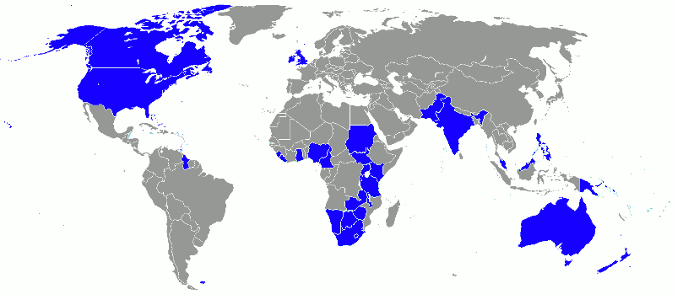
Supplement 1
Map “The spread of English” (Wikipedia.org)

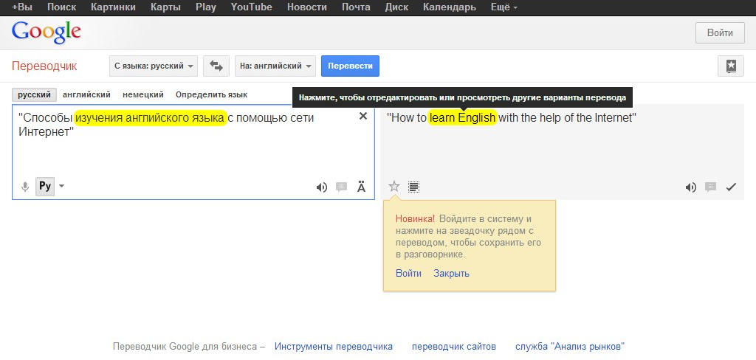
Supplement 2
Picture “On-line translator” (google.ru)

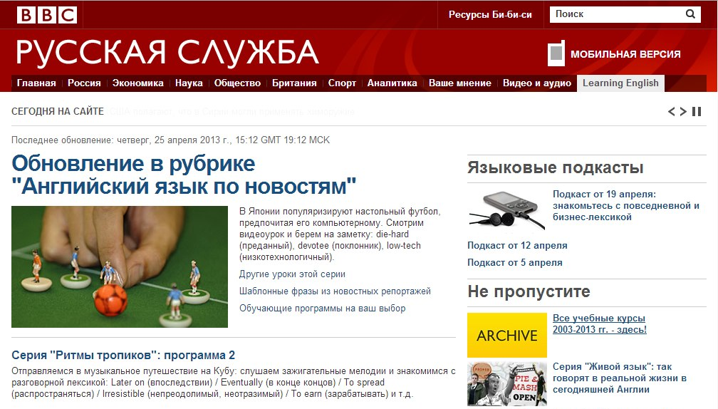
Supplement 3
Picture “BBC” (bbc.co.uk)

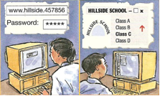
Supplement 4
Picture “On-line language laboratories” (Ellis P. Wilson K. 2002 – “Move Ahead Student’s book 1”, Macmillan, стр. 25)

Если бы у вас была возможность выбрать любой способ в изучении английского, какой способ вы бы выбрали?
(не более 2-х вариантов)
Специальные сайты с разделами для изучения
Социальные сети
«Скайп» (с англоговорящими репетиторами и носителями языка)
Виртуальный класс
Музыка на английском языке
Фильмы в оригинале
Чтение книг на английском языке

Supplement 5
Chart “Research”

Supplement 6
Diagram “Research results”

